**EXERCISE 1:**

**--SCENARIO 2**

BEGIN

    FOR cust IN (SELECT CustomerID, Name, DOB FROM Customers) LOOP

        IF MONTHS_BETWEEN(SYSDATE, cust.DOB) / 12 > 60 THEN

            UPDATE Loans

            SET InterestRate = InterestRate - 1

            WHERE CustomerID = cust.CustomerID;

            DBMS_OUTPUT.PUT_LINE('Interest discounted for: ' || cust.Name);

        END IF;

    END LOOP;

    COMMIT;

END;

/

ALTER TABLE Customers ADD IsVIP VARCHAR2(5);

**--SCENARIO 2**

BEGIN

   FOR rec IN (SELECT CustomerID, Balance FROM Customers) LOOP

      IF rec.Balance > 10000 THEN

         UPDATE Customers

         SET IsVIP = 'TRUE'

         WHERE CustomerID = rec.CustomerID;

      END IF;

   END LOOP;

   COMMIT;

END;

**--SCENARIO 2**

BEGIN

   FOR rec IN (

      SELECT c.Name, l.EndDate

      FROM Customers c

      INNER JOIN Loans l ON c.CustomerID = l.CustomerID

      WHERE l.EndDate BETWEEN SYSDATE AND SYSDATE + 30

   ) LOOP

      DBMS_OUTPUT.PUT_LINE('Reminder: Loan for ' || rec.Name ||

                           ' is due on ' || TO_CHAR(rec.EndDate, 'DD-MON-YYYY'));

   END LOOP;

END;

/

**OUTPUT:**

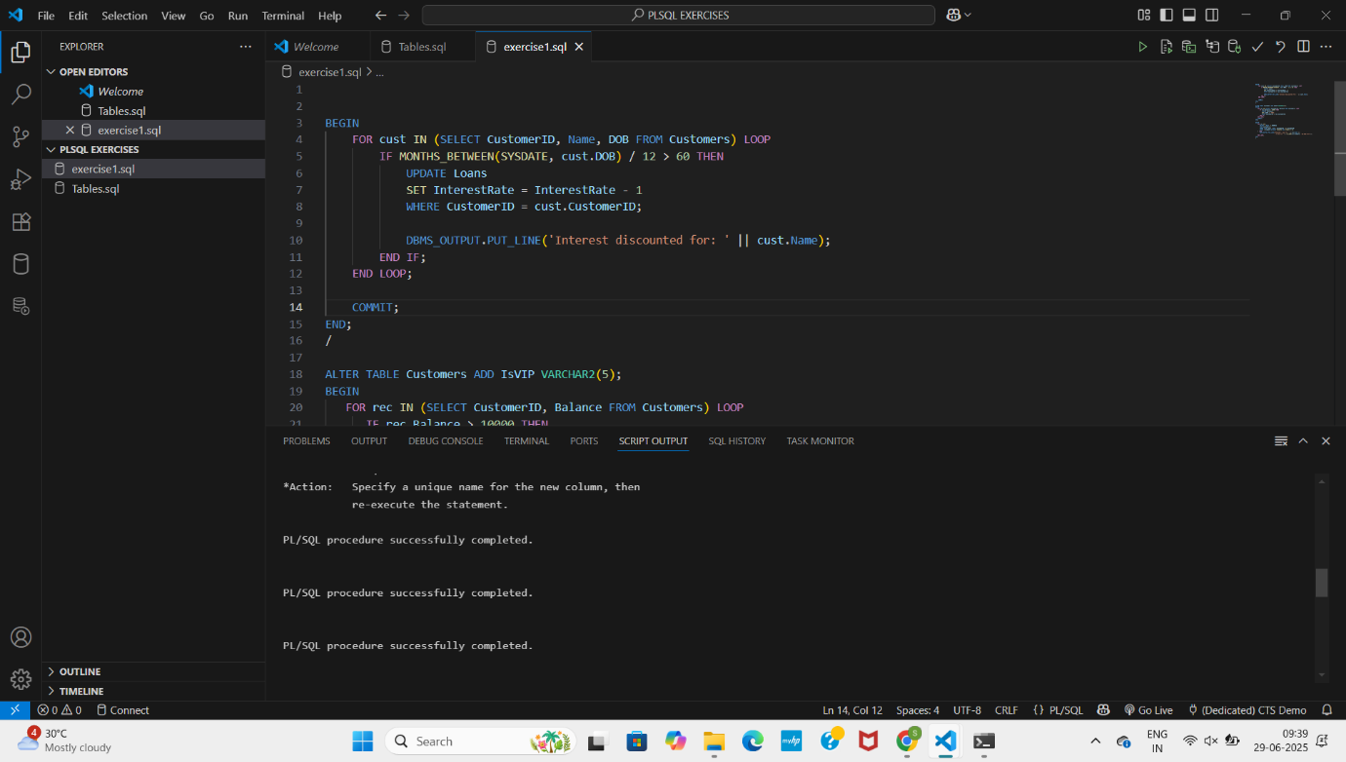

**EXERCISE 2:**

**--SCENARIO 1**

CREATE OR REPLACE PROCEDURE SafeTransferFunds(

  fromAcc NUMBER,

  toAcc NUMBER,

  amount NUMBER

) AS

  insufficient_funds EXCEPTION;

  fromBal NUMBER;

**--SCENARIO 2**

BEGIN

  SELECT Balance INTO fromBal FROM Accounts WHERE AccountID = fromAcc;

  IF fromBal < amount THEN

    RAISE insufficient_funds;

  END IF;

  UPDATE Accounts SET Balance = Balance - amount WHERE AccountID = fromAcc;

  UPDATE Accounts SET Balance = Balance + amount WHERE AccountID = toAcc;

  COMMIT;

EXCEPTION

  WHEN insufficient_funds THEN

    ROLLBACK;

    DBMS_OUTPUT.PUT_LINE('Transfer failed: Insufficient funds.');

  WHEN OTHERS THEN

    ROLLBACK;

    DBMS_OUTPUT.PUT_LINE('Transfer failed: ' || SQLERRM);

END;

/

**--SCENARIO 3**

CREATE OR REPLACE PROCEDURE UpdateSalary(

  empID NUMBER,

  percent NUMBER

) AS

BEGIN

  UPDATE Employees SET Salary = Salary + (Salary * percent / 100)

  WHERE EmployeeID = empID;

  IF SQL%NOTFOUND THEN

    RAISE_APPLICATION_ERROR(-20001, 'Employee not found');

  END IF;

EXCEPTION

  WHEN OTHERS THEN

    DBMS_OUTPUT.PUT_LINE('Error: ' || SQLERRM);

END;

/

**OUTPUT:**

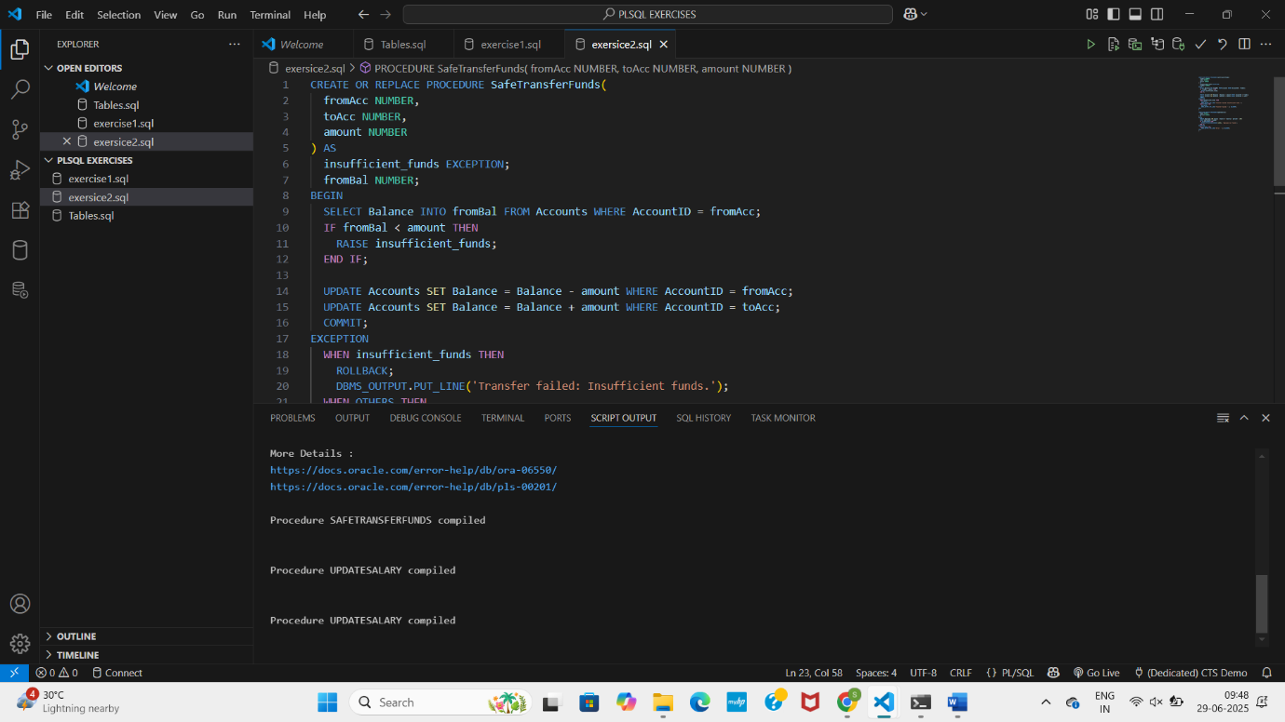

**EXERCISE 3:**

**--SCENARIO 1**

CREATE OR REPLACE PROCEDURE ProcessMonthlyInterest IS

BEGIN

  UPDATE Accounts

  SET Balance = Balance + (Balance * 0.01)

  WHERE AccountType = 'Savings';

END;

/

**--SCENARIO 2**

CREATE OR REPLACE PROCEDURE UpdateEmployeeBonus(

  dept IN VARCHAR2,

  bonusPercent IN NUMBER

) AS

BEGIN

  UPDATE Employees

  SET Salary = Salary + (Salary * bonusPercent / 100)

  WHERE Department = dept;

END;

/

**--SCENARIO 3**

CREATE OR REPLACE PROCEDURE TransferFunds(

  fromAcc IN NUMBER,

  toAcc IN NUMBER,

  amount IN NUMBER

) AS

  fromBal NUMBER;

BEGIN

  SELECT Balance INTO fromBal FROM Accounts WHERE AccountID = fromAcc;

  IF fromBal < amount THEN

    DBMS_OUTPUT.PUT_LINE('Insufficient funds.');

    RETURN;

  END IF;

  UPDATE Accounts SET Balance = Balance - amount WHERE AccountID = fromAcc;

  UPDATE Accounts SET Balance = Balance + amount WHERE AccountID = toAcc;

  COMMIT;

END;

/

**OUTPUT:**

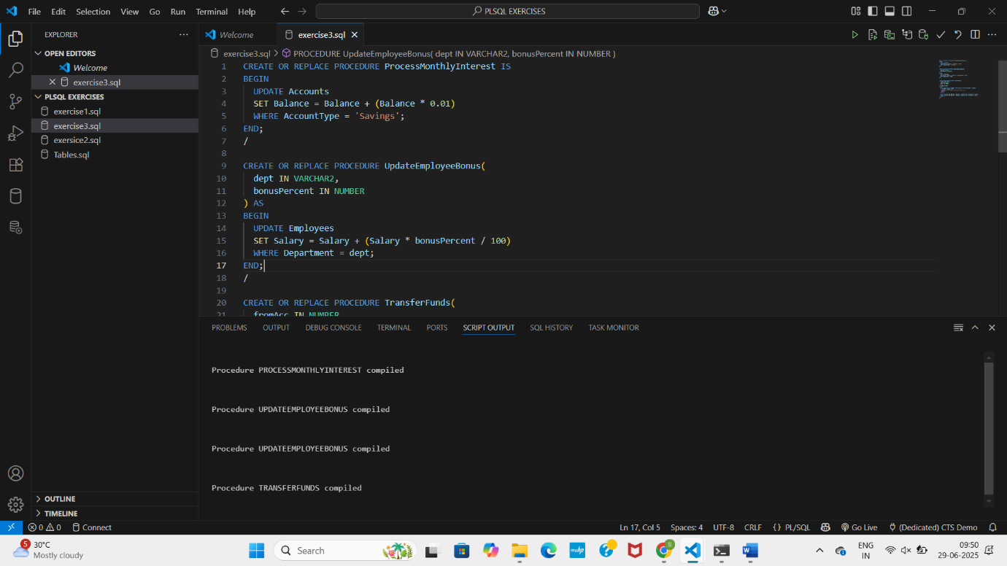

**EXERCISE 4:**

**-- Scenario 1**

CREATE OR REPLACE FUNCTION CalculateAge(dob DATE) RETURN NUMBER IS

BEGIN

  RETURN FLOOR(MONTHS_BETWEEN(SYSDATE, dob) / 12);

END;

/

**-- Scenario 2**

CREATE OR REPLACE FUNCTION CalculateMonthlyInstallment(

  amount NUMBER,

  rate NUMBER,

  years NUMBER

) RETURN NUMBER IS

  monthlyRate NUMBER := rate / (12 * 100);

  months NUMBER := years * 12;

BEGIN

  RETURN (amount * monthlyRate) / (1 - POWER(1 + monthlyRate, -months));

END;

/

**-- Scenario 3**

CREATE OR REPLACE FUNCTION HasSufficientBalance(

  accID NUMBER,

  amt NUMBER

) RETURN BOOLEAN IS

  bal NUMBER;

BEGIN

  SELECT Balance INTO bal FROM Accounts WHERE AccountID = accID;

  RETURN bal >= amt;

EXCEPTION

  WHEN OTHERS THEN

    RETURN FALSE;

END;

/

**OUTPUT:**

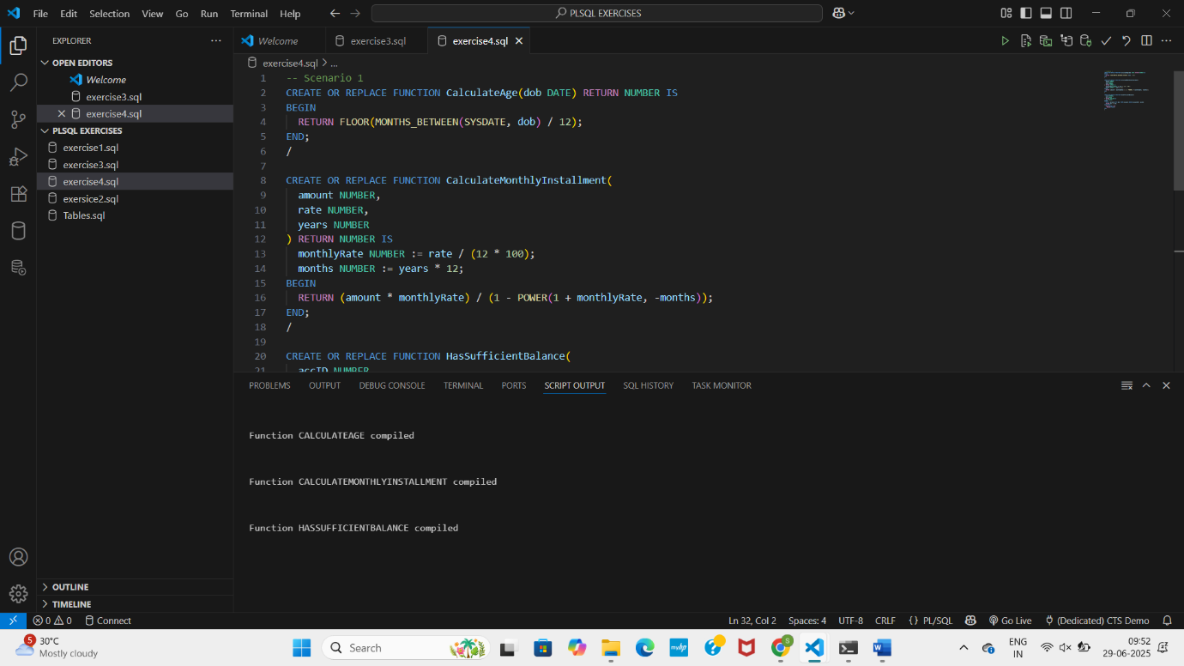

**EXERCISE 5:**

**--Scenario 1**

CREATE OR REPLACE TRIGGER UpdateCustomerLastModified

BEFORE UPDATE ON Customers

FOR EACH ROW

BEGIN

  :NEW.LastModified := SYSDATE;

END;

/

**--Scenario 2**

CREATE TABLE AuditLog (

  LogID NUMBER GENERATED BY DEFAULT AS IDENTITY PRIMARY KEY,

  TransactionID NUMBER,

  LogDate DATE DEFAULT SYSDATE

);

CREATE OR REPLACE TRIGGER LogTransaction

AFTER INSERT ON Transactions

FOR EACH ROW

BEGIN

  INSERT INTO AuditLog(TransactionID)

  VALUES(:NEW.TransactionID);

END;

/

**--SCENARIO 3**

CREATE OR REPLACE TRIGGER CheckTransactionRules

BEFORE INSERT ON Transactions

FOR EACH ROW

DECLARE

  accBalance NUMBER;

BEGIN

  SELECT Balance INTO accBalance FROM Accounts WHERE AccountID = :NEW.AccountID;

  IF :NEW.TransactionType = 'Withdrawal' THEN

    IF :NEW.Amount > accBalance THEN

      RAISE_APPLICATION_ERROR(-20002, 'Insufficient balance for withdrawal');

    END IF;

  ELSIF :NEW.TransactionType = 'Deposit' THEN

    IF :NEW.Amount <= 0 THEN

      RAISE_APPLICATION_ERROR(-20003, 'Deposit amount must be positive');

    END IF;

  ELSE

    RAISE_APPLICATION_ERROR(-20004, 'Invalid transaction type');

  END IF;

END;

/

**OUTPUT:**

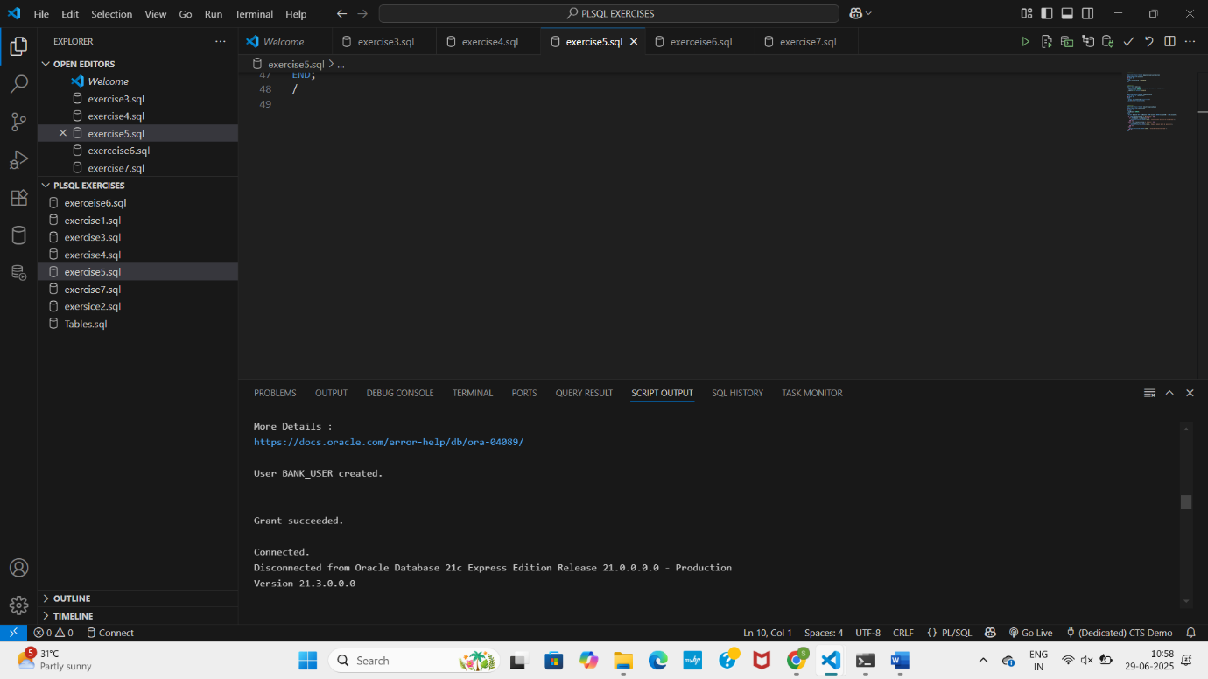

**EXERCISE 6:**

**-- Scenario 1**

DECLARE

  CURSOR cur IS

    SELECT c.CustomerID, c.Name, t.Amount, t.TransactionDate

    FROM Customers c

    JOIN Accounts a ON c.CustomerID = a.CustomerID

    JOIN Transactions t ON a.AccountID = t.AccountID

    WHERE TO_CHAR(t.TransactionDate, 'MMYYYY') = TO_CHAR(SYSDATE, 'MMYYYY');

BEGIN

  FOR rec IN cur LOOP

    DBMS_OUTPUT.PUT_LINE('Customer: ' || rec.Name || ' - ' || rec.TransactionDate || ' - Amount: ' || rec.Amount);

  END LOOP;

END;

/

**-- Scenario 2**

DECLARE

  CURSOR acc_cur IS

    SELECT AccountID FROM Accounts;

BEGIN

  FOR acc IN acc_cur LOOP

    UPDATE Accounts SET Balance = Balance - 100 WHERE AccountID = acc.AccountID;

  END LOOP;

END;

/

**-- Scenario 3**

DECLARE

  CURSOR loan_cur IS

    SELECT LoanID FROM Loans;

BEGIN

  FOR l IN loan_cur LOOP

    UPDATE Loans SET InterestRate = InterestRate + 0.5 WHERE LoanID = l.LoanID;

  END LOOP;

END;

/

**OUTPUT:**

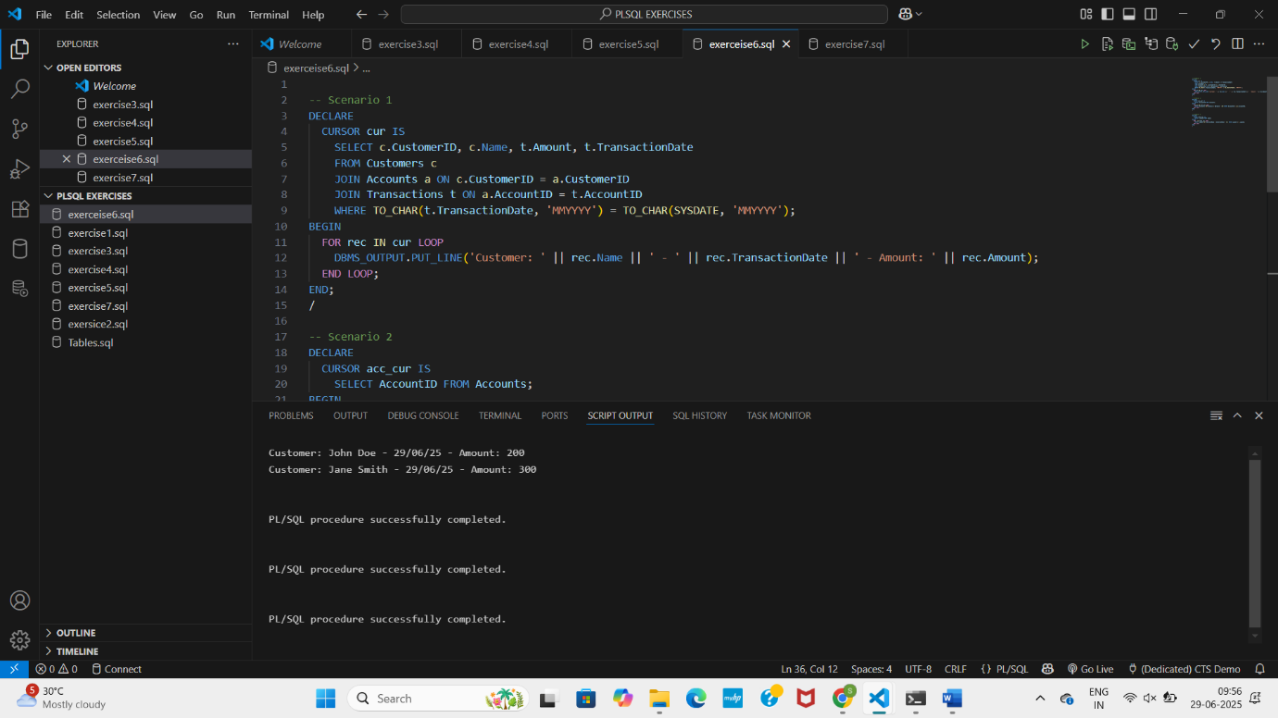

**EXERCISE 7:**

**-- Scenario 1**

CREATE OR REPLACE PACKAGE CustomerManagement AS

  PROCEDURE AddCustomer(id NUMBER, name VARCHAR2, dob DATE, bal NUMBER);

  PROCEDURE UpdateCustomer(id NUMBER, name VARCHAR2);

  FUNCTION GetCustomerBalance(id NUMBER) RETURN NUMBER;

END;

/

CREATE OR REPLACE PACKAGE BODY CustomerManagement AS

  PROCEDURE AddCustomer(id NUMBER, name VARCHAR2, dob DATE, bal NUMBER) IS

  BEGIN

    INSERT INTO Customers(CustomerID, Name, DOB, Balance, LastModified)

    VALUES (id, name, dob, bal, SYSDATE);

  END;

  PROCEDURE UpdateCustomer(id NUMBER, name VARCHAR2) IS

  BEGIN

    UPDATE Customers SET Name = name, LastModified = SYSDATE WHERE CustomerID = id;

  END;

  FUNCTION GetCustomerBalance(id NUMBER) RETURN NUMBER IS

    bal NUMBER;

  BEGIN

    SELECT Balance INTO bal FROM Customers WHERE CustomerID = id;

    RETURN bal;

  END;

END;

/

**-- Scenario 2**

CREATE OR REPLACE PACKAGE EmployeeManagement AS

  PROCEDURE HireEmployee(id NUMBER, name VARCHAR2, pos VARCHAR2, sal NUMBER, dept VARCHAR2);

  PROCEDURE UpdateEmployee(id NUMBER, pos VARCHAR2);

  FUNCTION GetAnnualSalary(id NUMBER) RETURN NUMBER;

END;

/

CREATE OR REPLACE PACKAGE BODY EmployeeManagement AS

  PROCEDURE HireEmployee(id NUMBER, name VARCHAR2, pos VARCHAR2, sal NUMBER, dept VARCHAR2) IS

  BEGIN

    INSERT INTO Employees(EmployeeID, Name, Position, Salary, Department, HireDate)

    VALUES (id, name, pos, sal, dept, SYSDATE);

  END;

  PROCEDURE UpdateEmployee(id NUMBER, pos VARCHAR2) IS

  BEGIN

    UPDATE Employees SET Position = pos WHERE EmployeeID = id;

  END;

  FUNCTION GetAnnualSalary(id NUMBER) RETURN NUMBER IS

    sal NUMBER;

  BEGIN

    SELECT Salary INTO sal FROM Employees WHERE EmployeeID = id;

    RETURN sal * 12;

  END;

END;

/

**-- Scenario 3**

CREATE OR REPLACE PACKAGE AccountOperations AS

  PROCEDURE OpenAccount(accID NUMBER, custID NUMBER, accType VARCHAR2, bal NUMBER);

  PROCEDURE CloseAccount(accID NUMBER);

  FUNCTION GetTotalBalance(custID NUMBER) RETURN NUMBER;

END;

/

CREATE OR REPLACE PACKAGE BODY AccountOperations AS

  PROCEDURE OpenAccount(accID NUMBER, custID NUMBER, accType VARCHAR2, bal NUMBER) IS

  BEGIN

    INSERT INTO Accounts(AccountID, CustomerID, AccountType, Balance, LastModified)

    VALUES (accID, custID, accType, bal, SYSDATE);

  END;

  PROCEDURE CloseAccount(accID NUMBER) IS

  BEGIN

    DELETE FROM Accounts WHERE AccountID = accID;

  END;

  FUNCTION GetTotalBalance(custID NUMBER) RETURN NUMBER IS

    total NUMBER;

  BEGIN

    SELECT SUM(Balance) INTO total FROM Accounts WHERE CustomerID = custID;

    RETURN total;

  END;

END;

/

**OUTPUT:**

